# Analysis of mouse data

## Method

I have analysed each cell type separately. I converted the proportion of cells of the given type to the logit scale, and fitted a Normal linear mixed model, with mouse type and time as the predictors and the logit proportion as response. Time was included as a 5-level factor. I have also considered stroke size, but it does not add to the explanation of the data, so I did not include this in the analysis.

I included a random intercept for each mouse, to take into account the correlations of repeated observations of the same mouse. The variables of interest are the mean proportion of cells for the two types of mice, at each point in time., as well as the interaction between mouse type and time.

All confidence intervals are 95%. There was a single occurrence of a zero count, and this I adjusted to the value one for practical reasons. All analysis was done in R version 3.6, with packages NMLE and LME4.

## Results

Initial analyses showed that cell counts for female mice, and for PLT mice, were quite different from male WT and T2 mice (in which we are primarily interested), so I removed them from the analysis.

We have 4 WT mice and 7 T2 mice. For each of 11 cell types, we have 15 observations for the WT mice, and 23 observations for the T2 mice, i.e. a total of 38 observations. The study is thus severely underpowered, and we can only hope to detect large effects.

Comparing WT mice and T2 mice at the same day, we find the following:

* The mean proportions for CD19pos_B220, CD19, CD19pos_B220pos_MHCII to be *lower* for T2 mice at days 0, 10 and 17.
* For CD11c, this is the case at days 3 and 10.
* mMDSCs_MHCII proportions are lower in T2 mice on days 10,17 and 24
* intMDSCs_MHCII are lower in T2 mice on days 10 and 24.
* CD11b proportions are *higher* in T2 mice at day 17;
* mMDSCs at days 0 and 10;
* gMDSCs at days 3,17 and 24;

There are no significant differences for intMDSCs and gMDSCs_MHCII cells.

## Analysis of variance.

|  |  |  |  |
| --- | --- | --- | --- |
| **Celltype** | **Type (t2/wt)** | **Time (1,..,24)** | **interaction** |
| CD19pos_B220 | **0.0094** | **0.0465** | 0.5118 |
| CD19 | **0.0184** | **0.0188** | 0.8498 |
| CD19pos_B220pos_MHCII | **0.0086** | **0.0480** | 0.5476 |
| CD11c | 0.0284 | 0.0003 | **0.0036** |
| CD11b | 0.0583 | **0.0091** | 0.4817 |
| mMDSCs | 0.2614 | < 1e-5 | **0.0023** |
| gMDSCs | **0.0283** | **0.0349** | 0.2904 |
| intMDSCs | 0.2014 | 0.1039 | 0.3143 |
| mMDSCs_MHCII | 0.0126 | 0.3620 | **0.0219** |
| gMDSCs_MHCII | 0.5438 | **0.0005** | 0.0926 |
| intMDSCs_MHCII | **0.0168** | 0.8351 | 0.0567 |

Analyis of variance: p-values for linear regression at the logit scale.

The interaction between mouse type and period is significant for cell types CD11c, mMDSCs and mMDSCs_MHCII: This tells us that, for these cell types, the time trajectory appears to differ for the two types of mice. For the remaining cell types, we see no evidence that the two types of mice respond differently over the five time periods. We see, however, significant main effects for all cell types, with the exception of intMDSCs.

In what follows, we look at this in detail, for each cell type. In all figures, WT are black, T2 mice are red.

## 1. CD19pos_B220

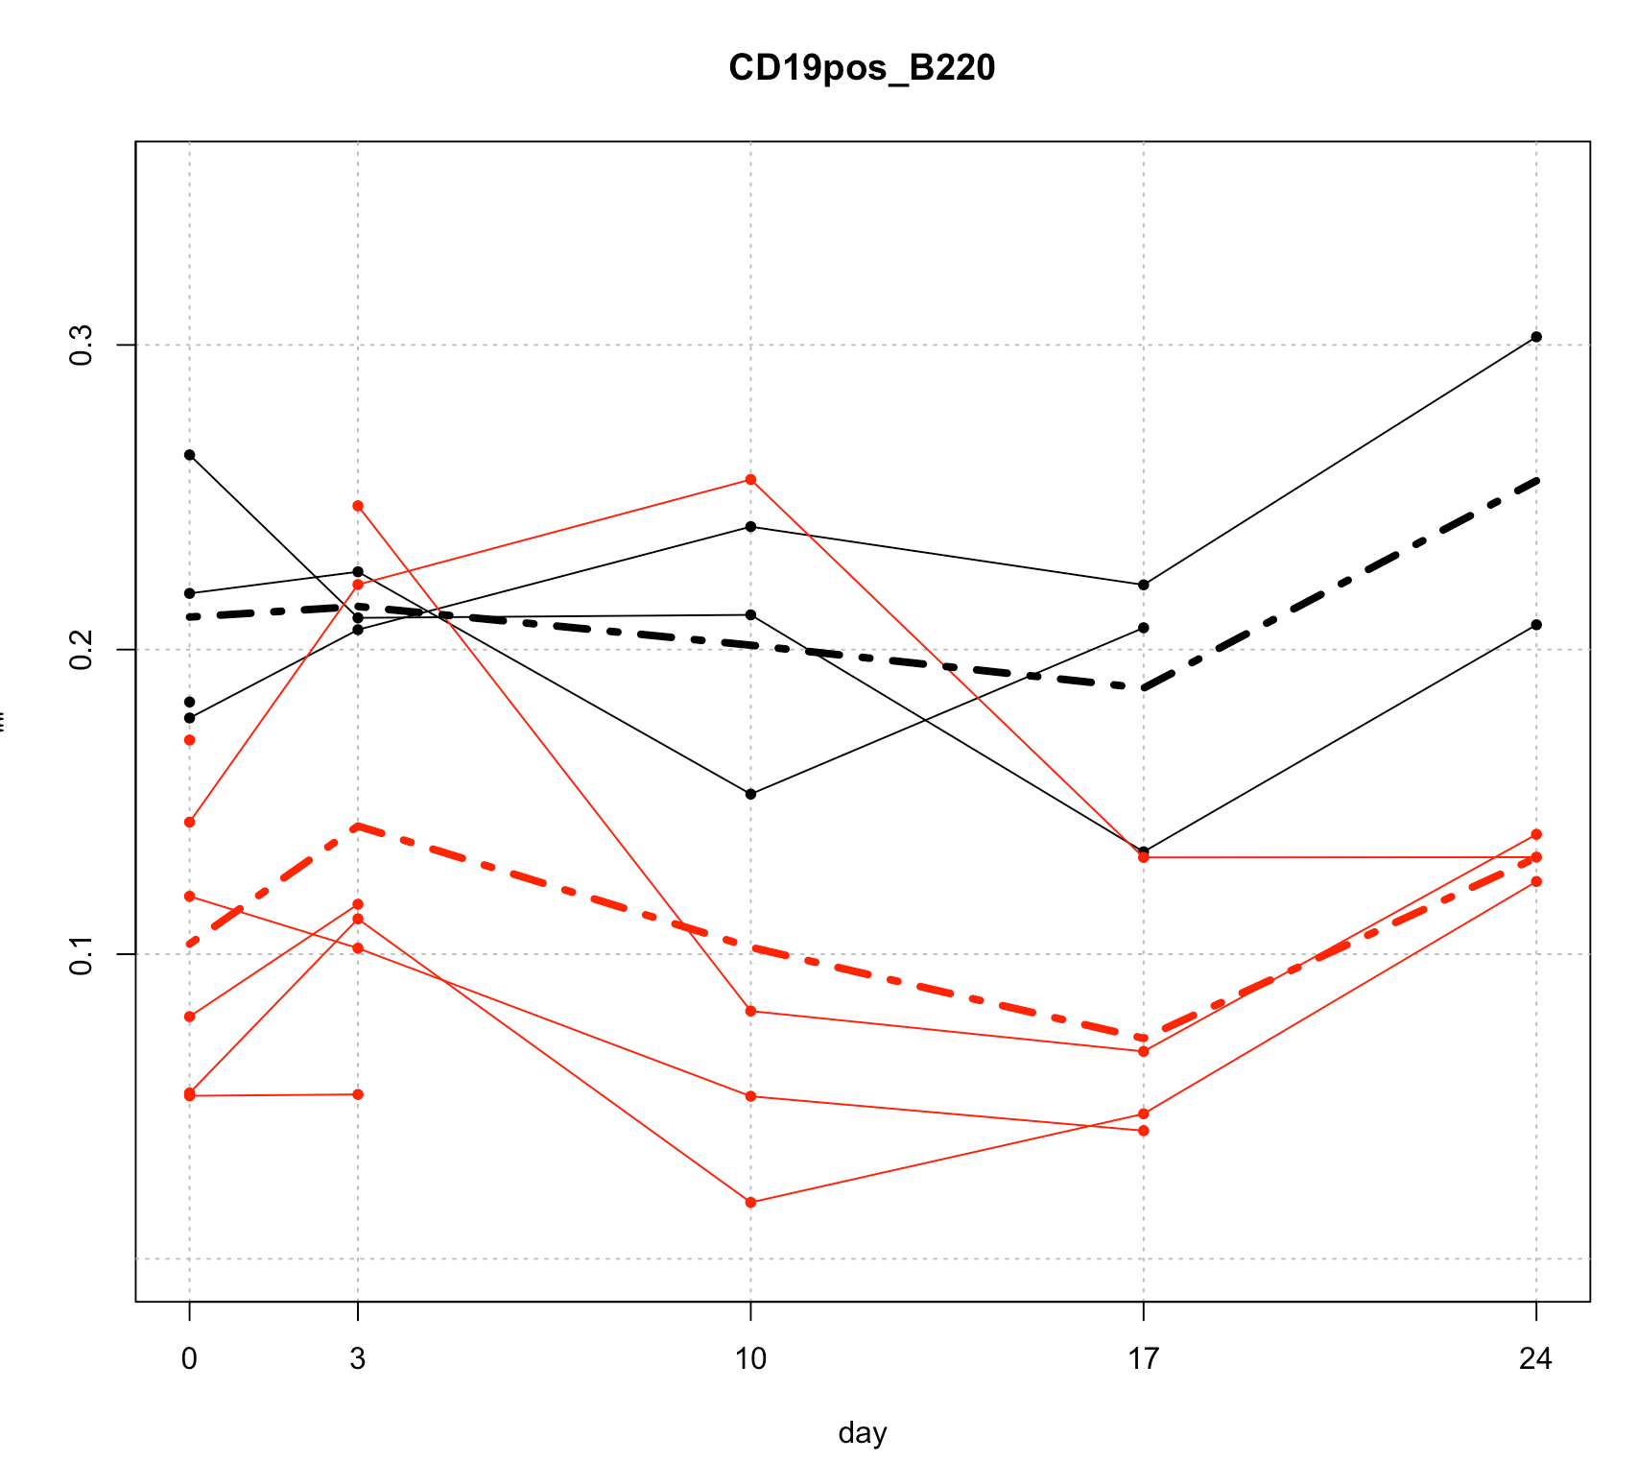

**data**

The proportion of cells appear to depend on the type, but not on the period.

mean proportion for WT cells : 0.21 [0.14-0.18]

mean proportion for T2 cells : 0.10 [0.08-0.14]

## 2. CD19

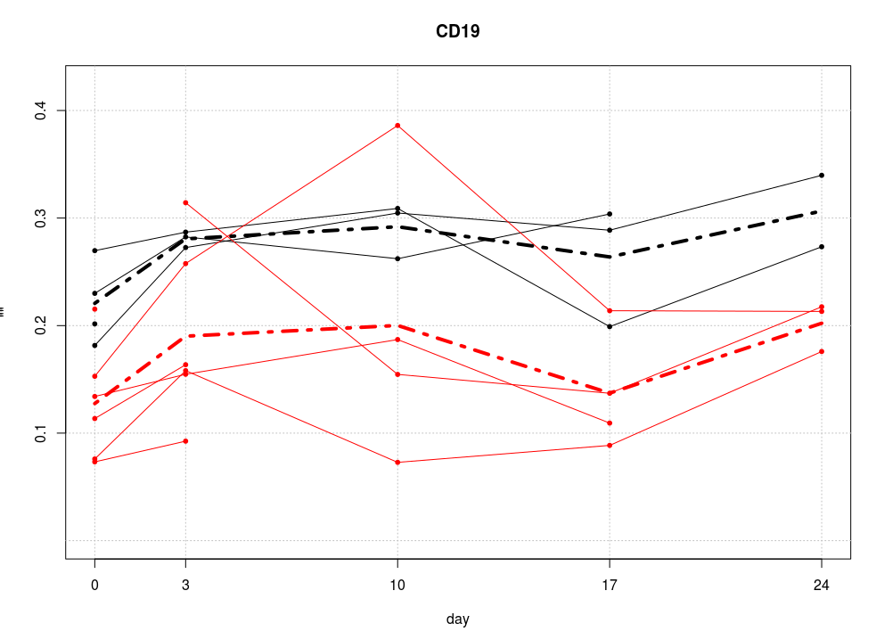

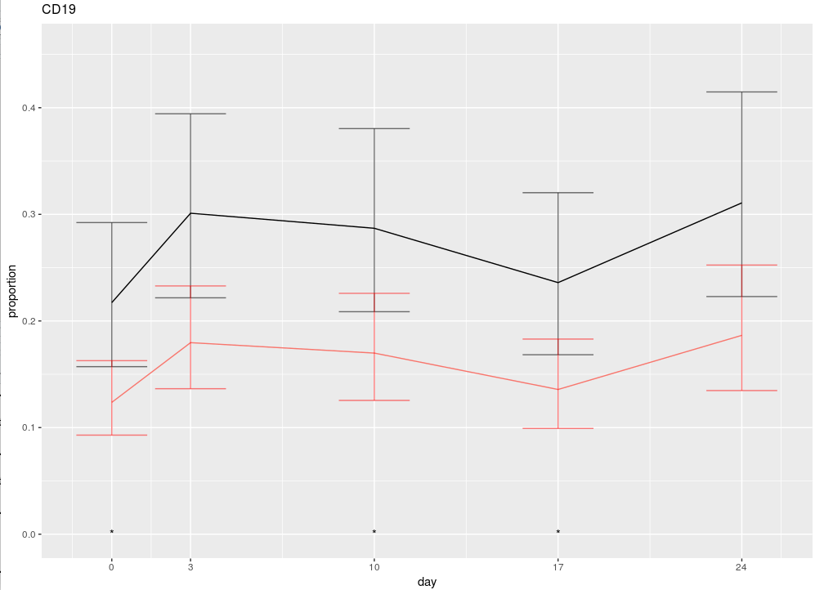

We have the following 95% CI for the proportions:

|  |  |  |  |  |
| --- | --- | --- | --- | --- |
| **Type** | **Time** | **estimate** | **Lower** | **upper** |
| WT | 0 | 0.22 | 0.16 | 0.29 |
|  | 3 | 0.30 | 0.22 | 0.39 |
|  | 10 | 0.29 | 0.21 | 0.38 |
|  | 17 | 0.24 | 0.17 | 0.22 |
|  | 24 | 0.31 | 0.22 | 0.41 |
| T2 | 0 | 0.12 | 0.09 | 0.16 |
|  | 3 | 0.18 | 0.14 | 0.23 |
|  | 10 | 0.17 | 0.13 | 0.23 |
|  | 17 | 0.14 | 0.10 | 0.18 |
|  | 24 | 0.19 | 0.13 | 0.25 |

Odds ratio’s

estimate lower upper

typeT2 0.51 0.34 0.77

factor(period)2 1.55 1.19 2.01

factor(period)3 1.45 1.09 1.93

factor(period)4 1.11 0.84 1.48

factor(period)5 1.63 1.18 2.25

In terms of odds ratios, we are about half as likely to see a T2 cell than a WT cell. All cell counts appear to increase after day 0, with the exception of period 4 (day 17)

## 3. CD19pos_B220pos_MHCII

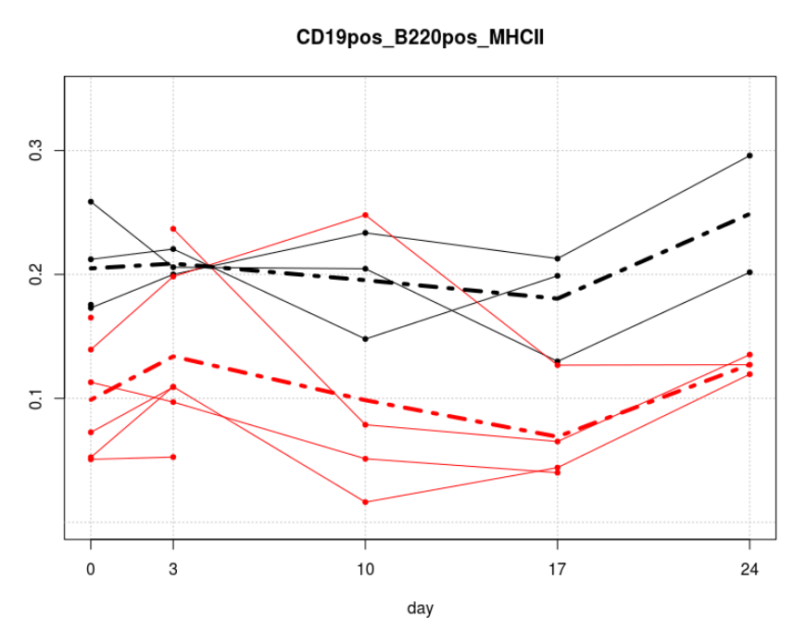

T2 cells are lower than WT cells, and there is no evidence for an effect of time.

mean proportion for WT cells : 0.13 [0.10-0.19]

mean proportion for T2 cells : 0.20 [0.14-0.26]

### 4. CD11C

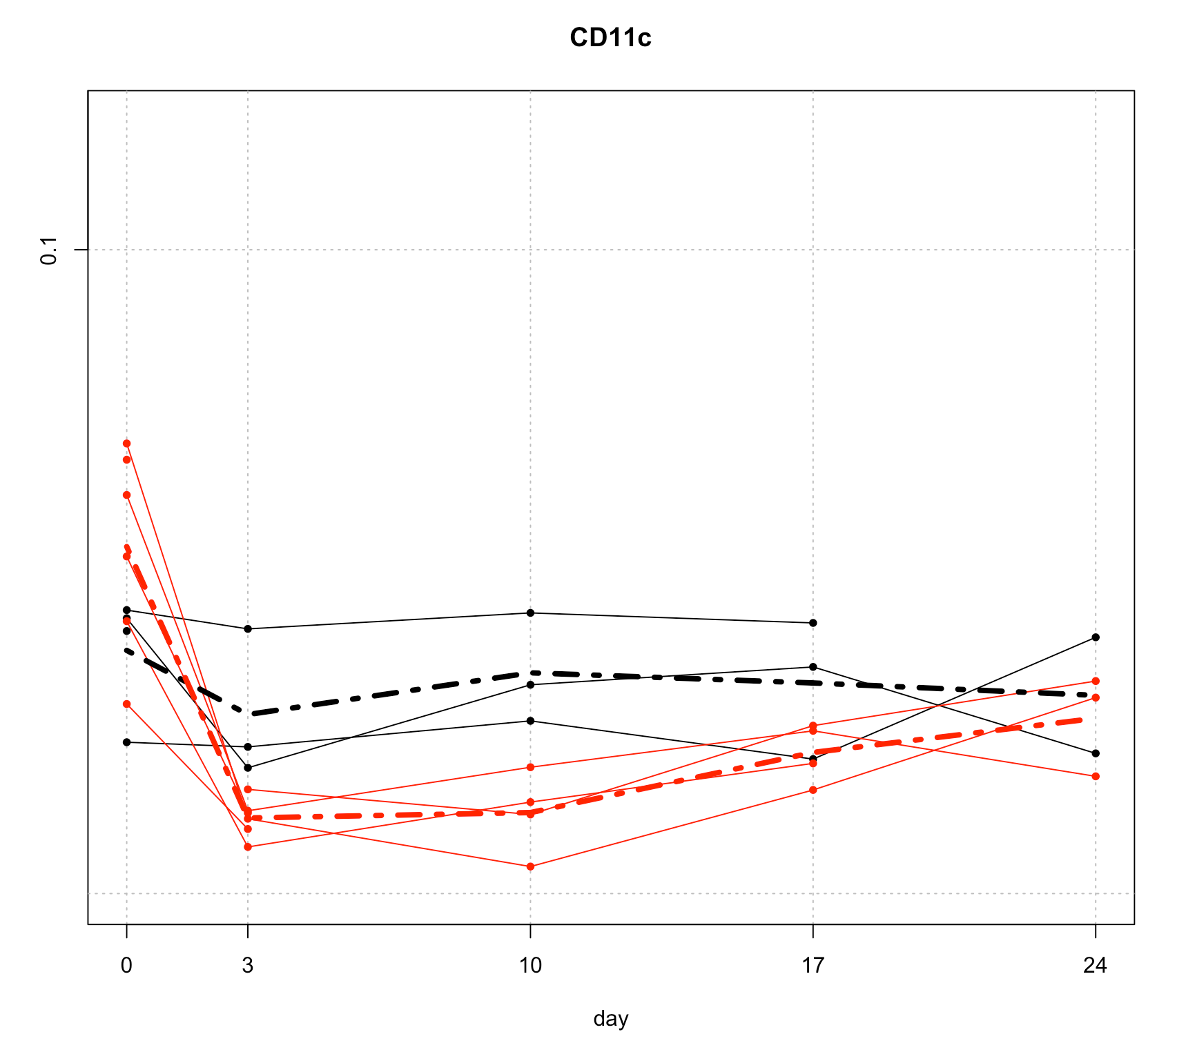

Here we may have an interation between time and type. T2 cells and WT cells respond differently over time.

numDF denDF F-value p-value

(Intercept) 1 19 2656.8587 <.0001

type 1 9 8.2129 0.0186

factor(period) 4 19 13.5725 <.0001

type:factor(period) 4 19 5.6633 0.0036

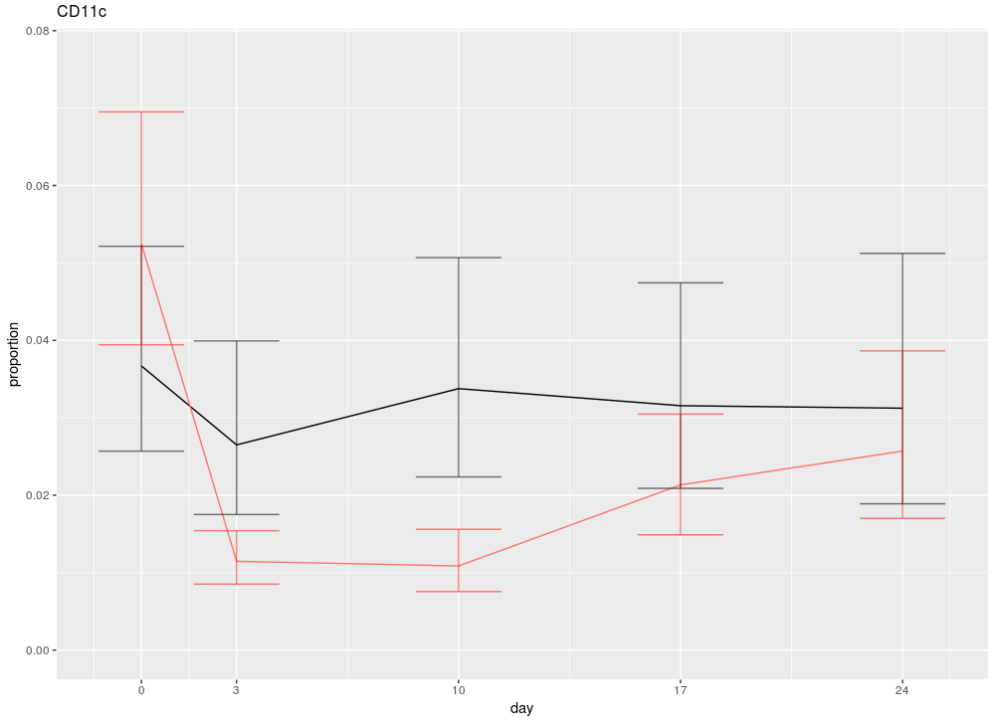

Confidence intervals for means:

|  |  |  |  |  |
| --- | --- | --- | --- | --- |
|  | period | Estimate | Lower | upper |
| WT | 0 | 0.04 | 0.03 | 0.05 |
|  | 3 | 0.03 | 0.02 | 0.04 |
|  | 10 | 0.03 | 0.02 | 0.05 |
|  | 17 | 0.03 | 0.02 | 0.05 |
|  | 24 | 0.03 | 0.02 | 0.05 |
| T2 | 0 | 0.05 | 0.04 | 0.07 |
|  | 3 | 0.01 | 0.01 | 0.02 |
|  | 10 | 0.01 | 0.01 | 0.02 |
|  | 17 | 0.02 | 0.01 | 0.03 |
|  | 24 | 0.03 | 0.02 | 0.04 |

So this is one where T2 and WT cells respond differently over time. Notice, though, that the proportions are an order of magnitude smaller than at the previous celltypes. If there is any measurement error, then that might affect these cells more than others.

## 5. CD11b

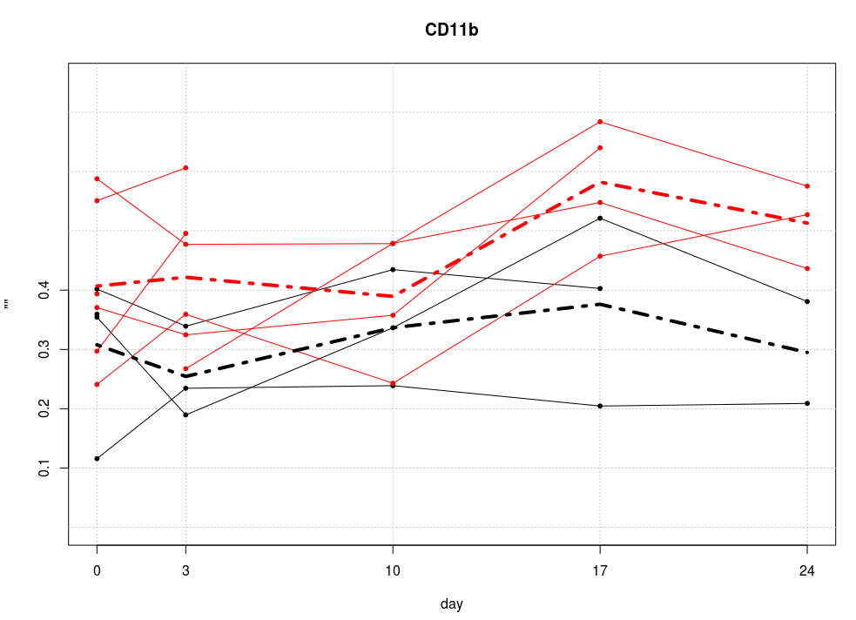

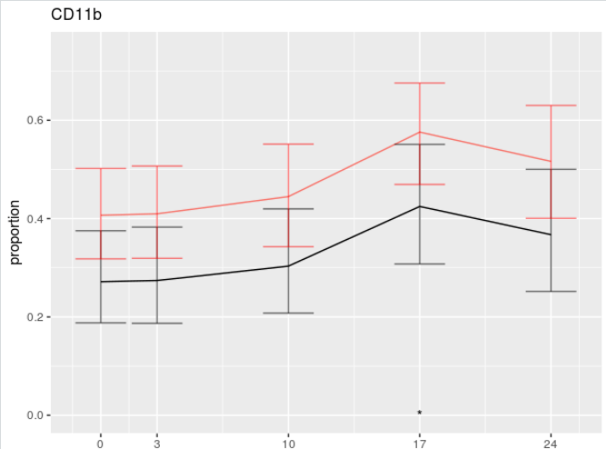

There seem to be more T2 cells, but there is a lot of overlap, and we have no evidence for a difference. Both types of cells respond over time in the same way.

## 6. mMDSCs

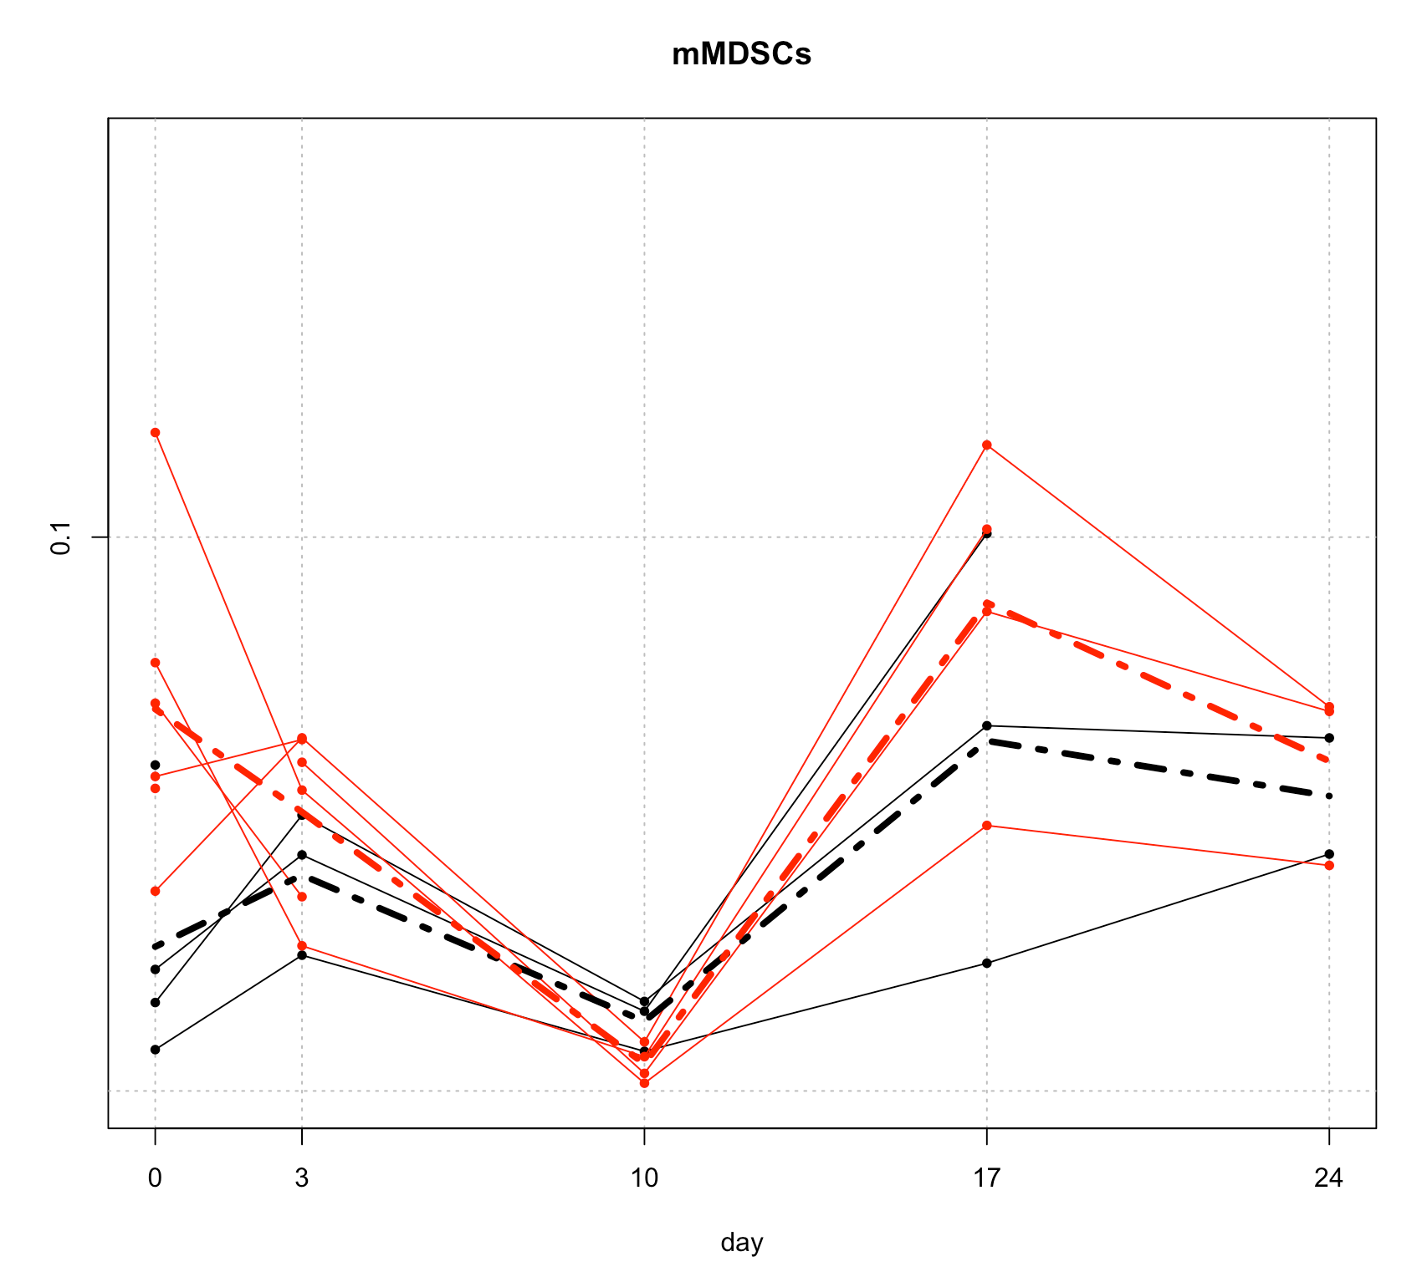

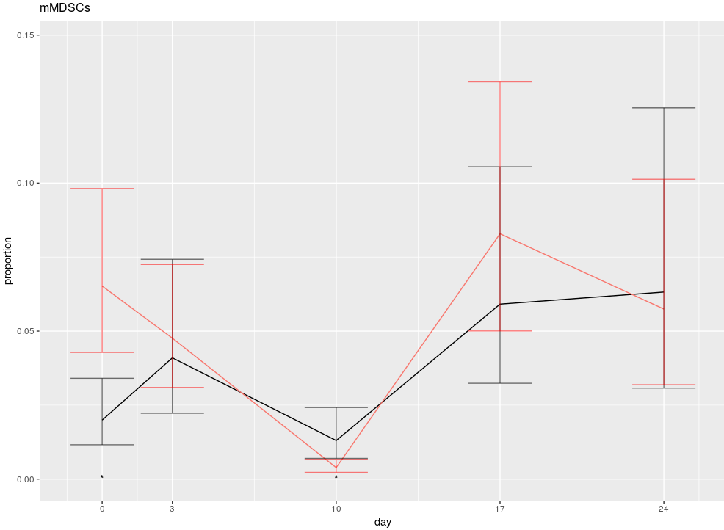

Here we have some evidence for an interaction between time and type.

|  |  |  |  |  |
| --- | --- | --- | --- | --- |
| **Type** | **Time** | **Estimate** | **Lower** | **upper** |
| WT | 0 | 0.02 | 0.01 | 0.03 |
|  | 3 | 0.04 | 0.02 | 0.07 |
|  | 10 | 0.01 | 0.01 | 0.02 |
|  | 17 | 0.06 | 0.03 | 0.11 |
|  | 24 | 0.06 | 0.03 | 0.13 |
| T2 | 0 | 0.07 | 0.04 | 0.10 |
|  | 3 | 0.05 | 0.03 | 0.07 |
|  | 10 | 0.00 | 0.00 | 0.01 |
|  | 17 | 0.08 | 0.05 | 0.13 |
|  | 24 | 0.06 | 0.03 | 0.10 |

## 7. gMDSCs

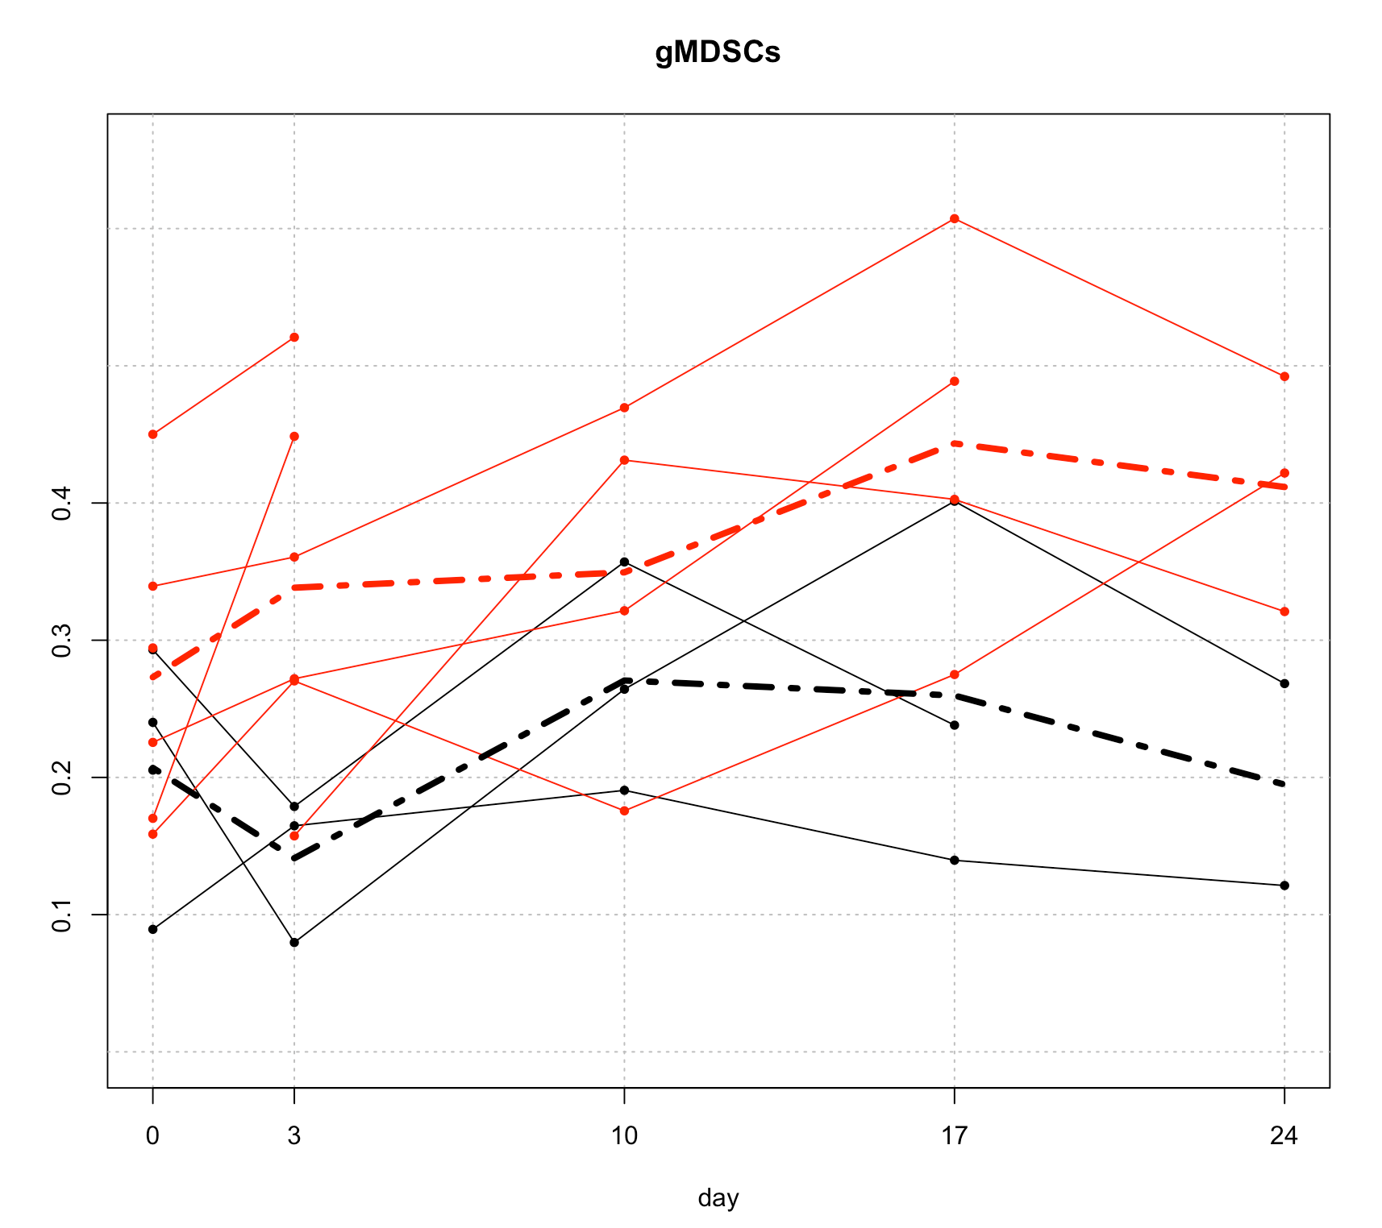

|  |  |  |  |  |
| --- | --- | --- | --- | --- |
| **Type** | **Period** | **Estimate** | **Lower** | **upper** |
| WT | 0 | 0.16 | 0.10 | 0.24 |
|  | 3 | 0.17 | 0.11 | 0.26 |
|  | 10 | 0.24 | 0.15 | 0.35 |
|  | 17 | 0.28 | 0.18 | 0.40 |
|  | 24 | 0.25 | 0.15 | 0.37 |
| T2 | 0 | 0.29 | 0.21 | 0.38 |
|  | 3 | 0.30 | 0.22 | 0.40 |
|  | 10 | 0.40 | 0.29 | 0.51 |
|  | 17 | 0.45 | 0.33 | 0.56 |
|  | 24 | 0.41 | 0.29 | 0.54 |

## 8. intMDSCs

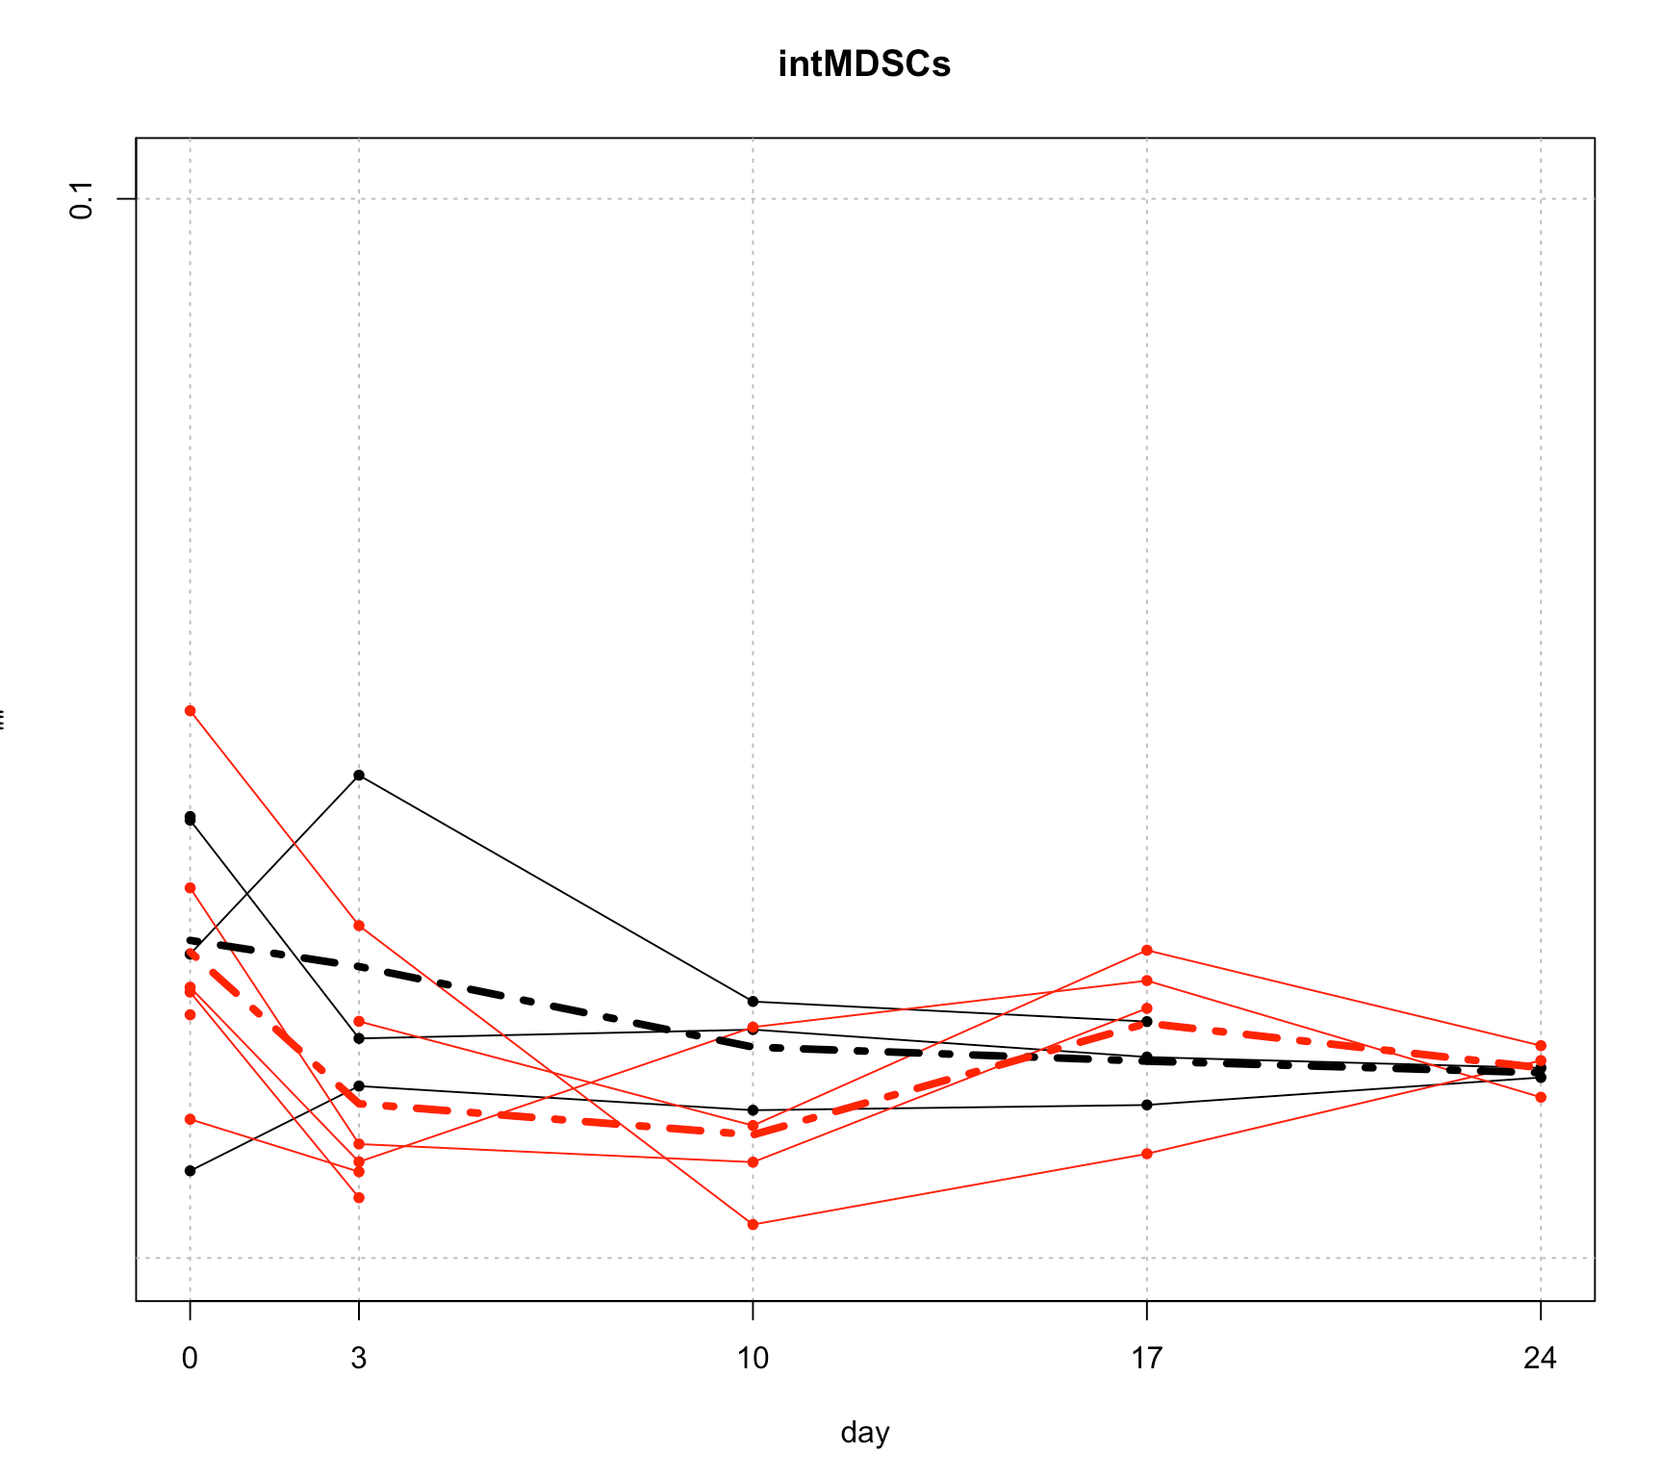

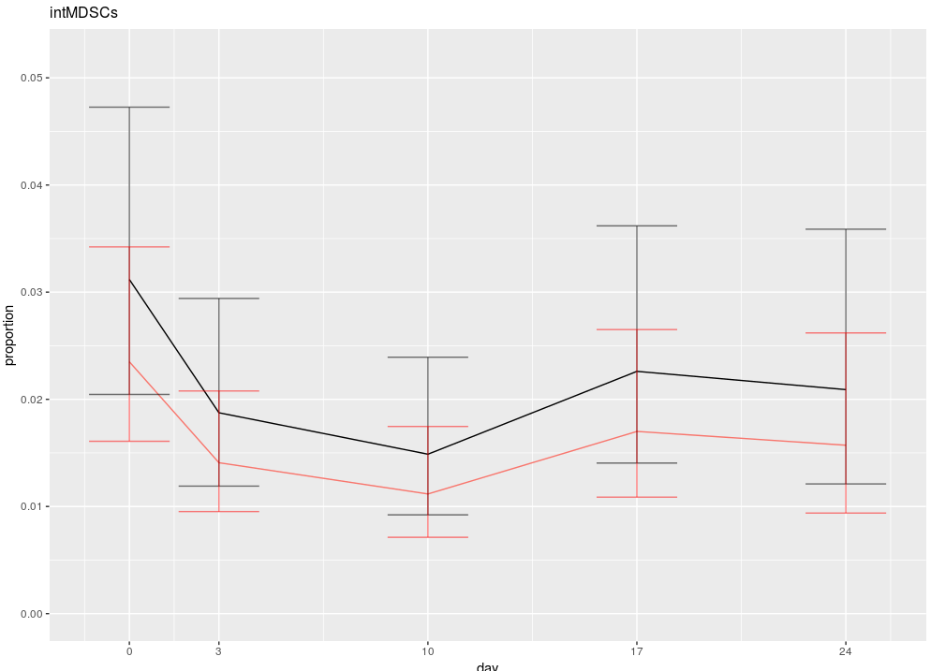

There is no evidence here for a difference between the two cell types, and they both vary very slightly over time.

|  |  |  |  |  |
| --- | --- | --- | --- | --- |
| Type | **Period** | **Estimate** | **Low** | **upp** |
| WT | 0 | 0.03 | 0.02 | 0.05 |
|  | 3 | 0.02 | 0.01 | 0.03 |
|  | 10 | 0.01 | 0.01 | 0.02 |
|  | 17 | 0.02 | 0.01 | 0.04 |
|  | 24 | 0.02 | 0.01 | 0.04 |
| T2 | 0 | 0.02 | 0.02 | 0.03 |
|  | 3 | 0.01 | 0.01 | 0.02 |
|  | 10 | 0.01 | 0.01 | 0.02 |
|  | 17 | 0.02 | 0.01 | 0.03 |
|  | 24 | 0.02 | 0.01 | 0.03 |

## 9. MDSCSs_MHCII

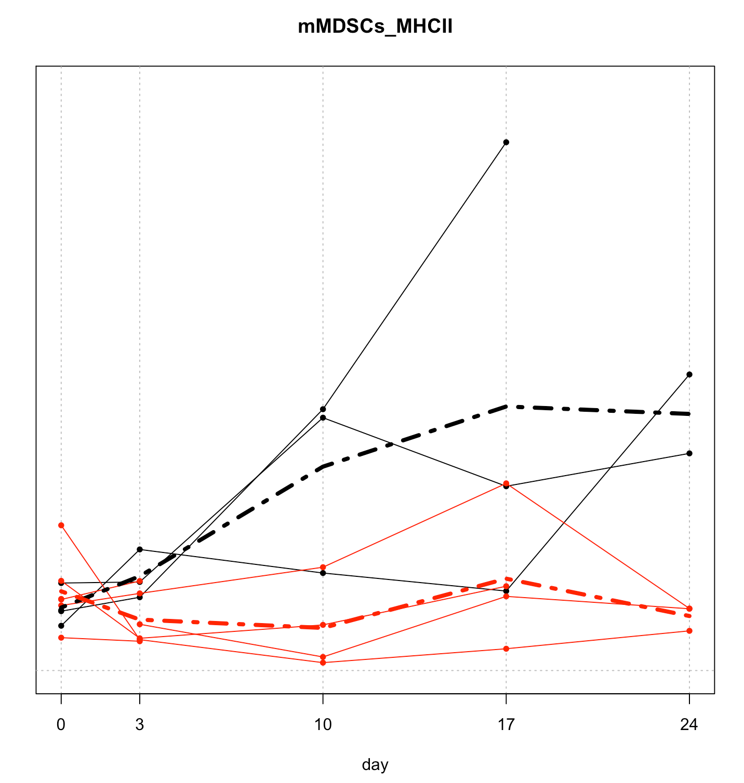

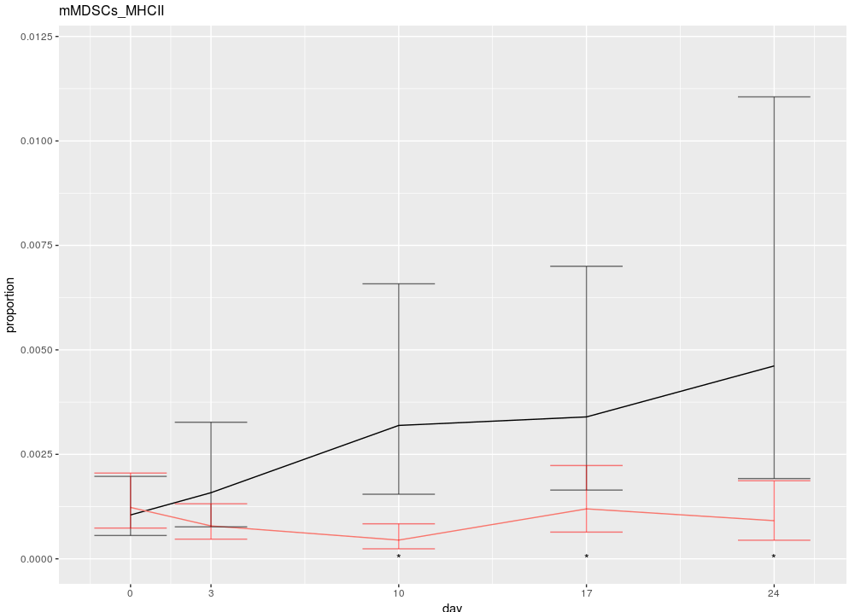

The cell counts here are very low, note the scale on the y-axis. We do have some evidence for an interaction. It appears that WT increase ever so slightly over time, but T2’s do not

## 10. gMDSCs_MHCII

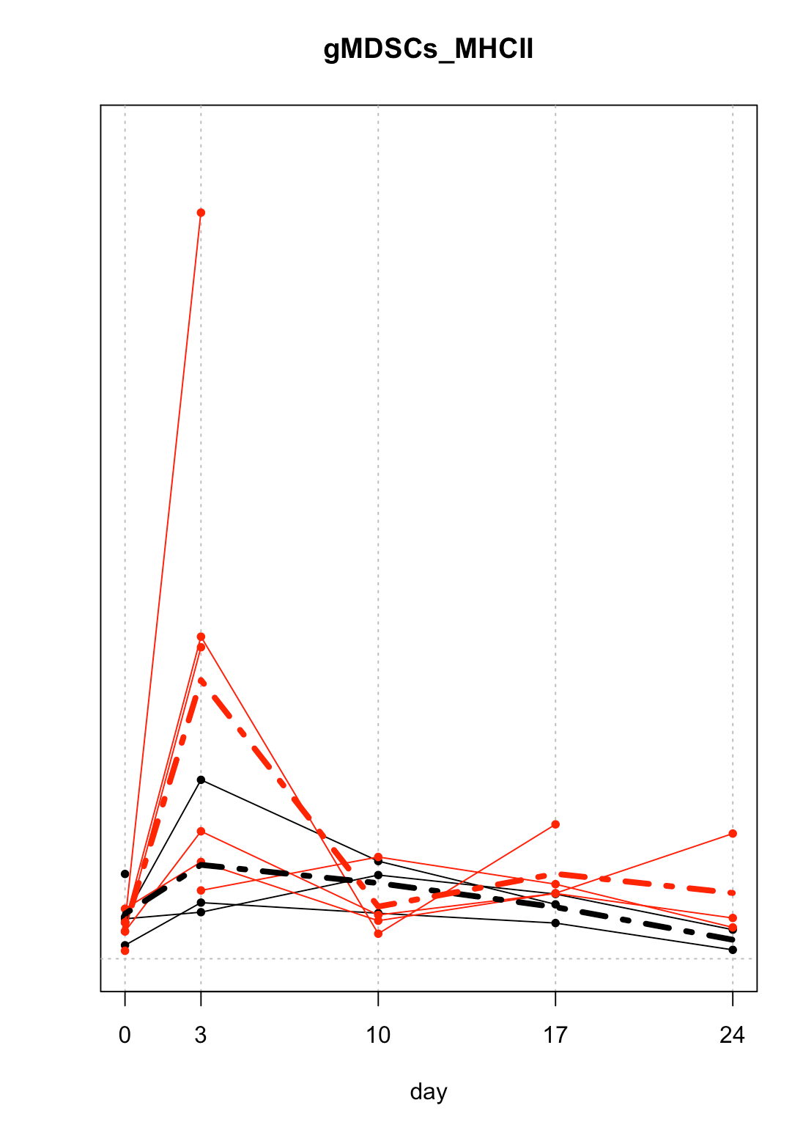

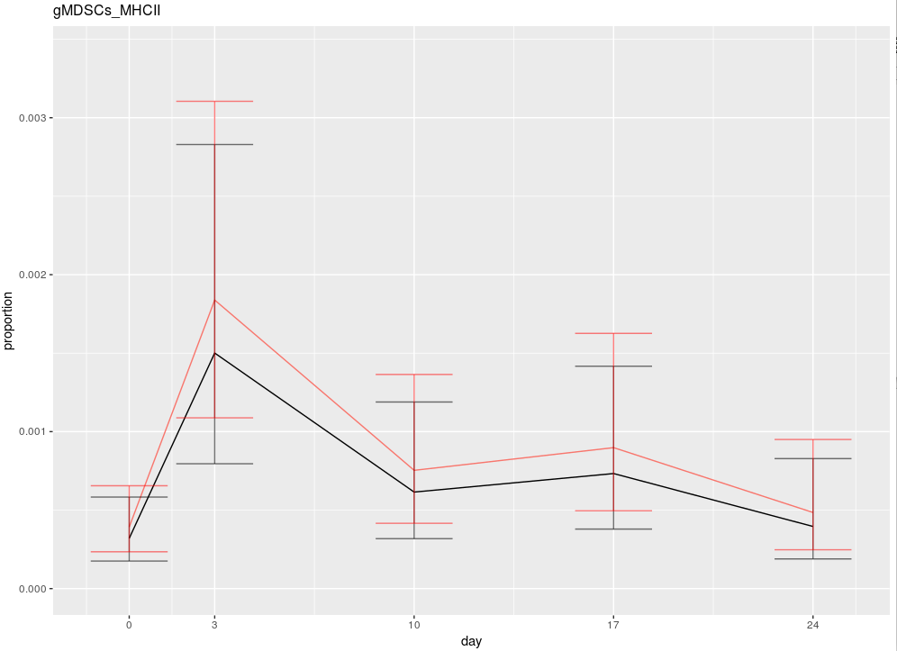

The two cell types behave pretty much identically.

## 11. intMDSCs_MHCII

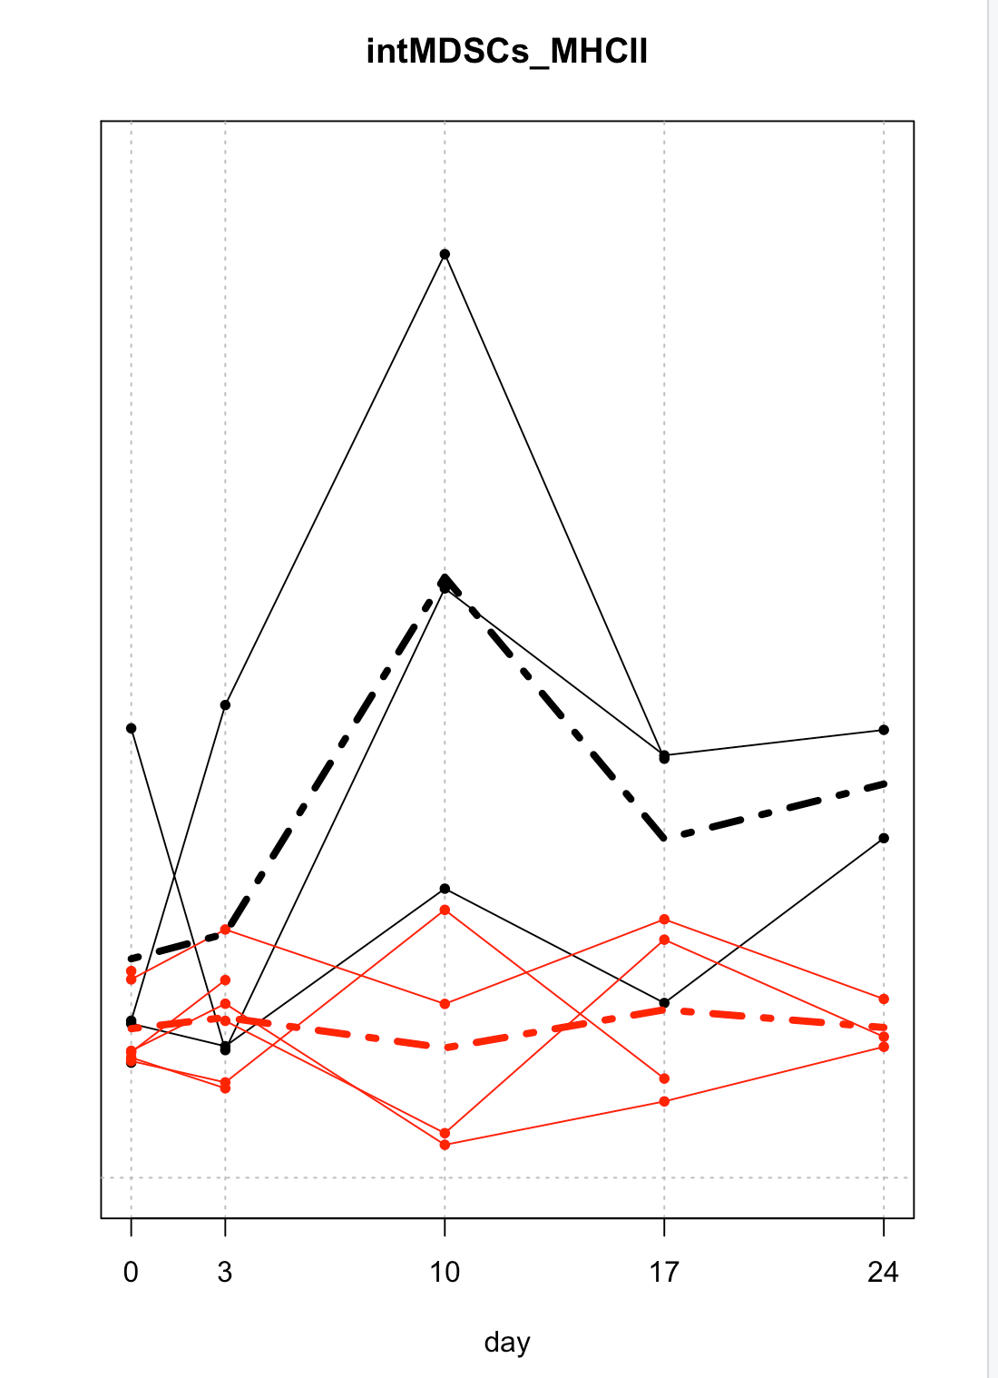

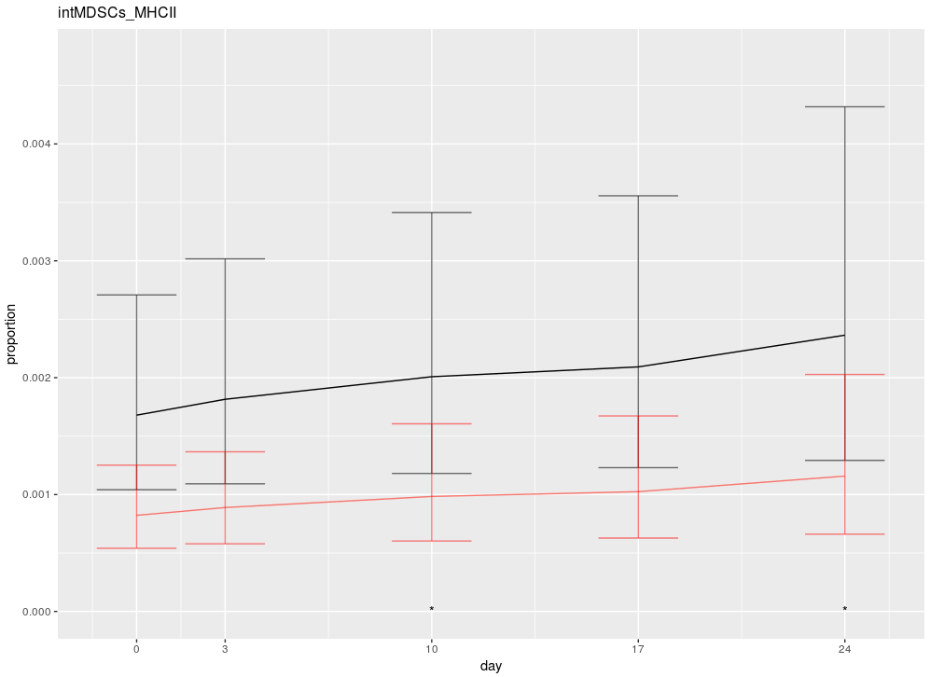

There is a difference between the types, and it is pretty much constant over time. Nothing happens after day zero.